# 24-1 HSRP Configuration – Lab Exercise

In this lab you will configure and test HSRP for a small campus network.

## Lab Topology

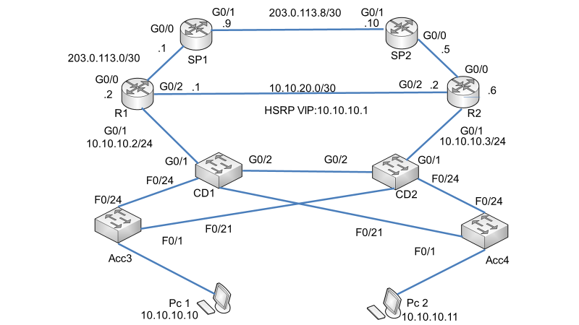

## Load the Startup Configurations

[Download the ‘24-1 HSRP Configuration.zip’ file here.](https://www.flackbox.com/ccna-project-files)

## Basic HSRP

1. Configure basic HSRP for the 10.10.10.0/24 network using the IP addresses shown in the topology diagram.
2. Wait for HSRP to come up on both routers and then check which is the active router.
3. Verify that the PCs can ping their default gateway using the HSRP address 10.10.10.1.
4. Verify that the PCs have upstream connectivity via their HSRP default gateway. Ping SP1 at 203.0.113.1
5. What is the MAC address on the physical interface of the active router?
6. What is the MAC address of the HSRP virtual interface?
7. Verify the PCs are using the virtual MAC address for their default gateway.

## Priority and Pre-emption

1. Configure HSRP so that R1 will be the preferred router. Use a single command.
2. Which router do you expect will be active now? Verify this.
3. Ensure that R1 is the active router. Do not reboot.

## Test HSRP

1. Run a continuous ping to the HSRP IP address from PC1 with the ‘ping

10.10.10.1 –n 1000’ command.

1. Save the configuration on R1 then reboot.
2. View the ping output on PC1. You should see a few dropped pings as R2 transitions to active following the outage of R1.
3. Verify R2 has transitioned to HSRP active.
4. Wait for R1 to complete booting and HSRP to come up. Verify R1 transitions to HSRP active because pre-emption is enabled.
5. Hit ‘Ctrl-C’ to cancel the ping on PC1. If you scroll back you should see a dropped ping or two as R1 transitioned back to HSRP active.

# 24-1 HSRP Configuration - Answer Key

In this lab you will configure and test HSRP for a small campus network.

## Basic HSRP

1. Configure basic HSRP for the 10.10.10.0/24 network using the IP addresses shown in the topology diagram.

Check to see if the physical IP addresses for the HSRP interface GigabitEthernet0/1 have been configured on R1 and R2.

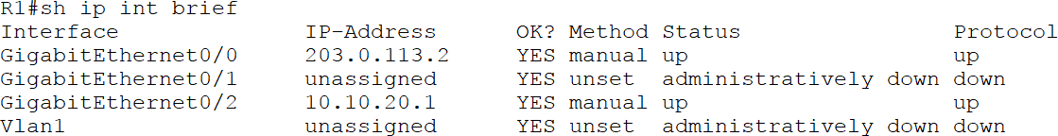

They haven’t been configured yet so correct that. We’ll do R1 first.

R1(config)#interface g0/1

R1(config-if)#ip address 10.10.10.2 255.255.255.0 R1(config-if)#no shutdown

Then add the virtual IP address.

R1(config-if)#standby 1 ip 10.10.10.1

Repeat on R2. Use a different physical address and the same virtual IP address.

R2(config)#interface g0/1

R2(config-if)#ip address 10.10.10.3 255.255.255.0 R2(config-if)#no shutdown

R2(config-if)#standby 1 ip 10.10.10.1

1. Wait for HSRP to come up on both routers and then check which is the active router.

Both routers have the same default priority so the router with the highest IP address will be preferred. If you complete the configuration on both routers before HSRP comes up on both then R2 will be active.

(If you configure HSRP on R1 before R2, and HSRP has already come up on R1 before HSRP comes up on R2, then R1 will be active.)

R1#show standby GigabitEthernet0/1 - Group 1 State is Standby

7 state changes, last state change 00:16:34 Virtual IP address is 10.10.10.1

Active virtual MAC address is 0000.0C07.AC01

Local virtual MAC address is 0000.0C07.AC01 (v1 default) Hello time 3 sec, hold time 10 sec

Next hello sent in 0.327 secs Preemption disabled

**Active router is 10.10.10.3 Standby router is local** Priority 100 (default 100)

Group name is hsrp-Gig0/1-1 (default)

1. Verify that the PCs can ping their default gateway using the HSRP address 10.10.10.1.

1. Verify that the PCs have upstream connectivity via their HSRP default gateway. Ping SP1 at 203.0.113.1

1. What is the MAC address on the physical interface of the active router?

R2#show interface g0/1

GigabitEthernet0/1 is up, line protocol is up (connected) Hardware is CN Gigabit Ethernet, address is **0001.6470.2502** *truncated*

MAC addresses may be different in your lab.

1. What is the MAC address of the HSRP virtual interface?

R2#show standby GigabitEthernet0/1 - Group 1 State is Active

1. state changes, last state change 00:16:22 Virtual IP address is 10.10.10.1

Active virtual MAC address is **0000.0C07.AC01**

Local virtual MAC address is 0000.0C07.AC01 (v1 default) Hello time 3 sec, hold time 10 sec

Next hello sent in 2.475 secs Preemption disabled

Active router is local Standby router is 10.10.10.2 Priority 100 (default 100)

Group name is hsrp-Gig0/1-1 (default)

1. Verify the PCs are using the virtual MAC address for their default gateway.

## Priority and Pre-emption

1. Configure HSRP so that R1 will be the preferred router. Use a single command.

R1(config)#interface g0/1

R1(config-if)#standby 1 priority 110

1. Which router do you expect will be active now? Verify this.

R2 will remain active because we didn’t configure pre-emption.

R1#show standby GigabitEthernet0/1 - Group 1 State is Standby

1. state changes, last state change 00:06:06 Virtual IP address is 10.10.10.1

Active virtual MAC address is 0000.0C07.AC01

Local virtual MAC address is 0000.0C07.AC01 (v1 default) Hello time 3 sec, hold time 10 sec

Next hello sent in 0.782 secs Preemption disabled

**Active router is 10.10.10.3** Standby router is local Priority 110 (configured 110)

Group name is hsrp-Gig0/1-1 (default)

1. Ensure that R1 is the active router. Do not reboot.

R1(config)#int g0/1

R1(config-if)#standby 1 preempt

R1#show standby GigabitEthernet0/1 - Group 1 State is Active

9 state changes, last state change 00:27:09 Virtual IP address is 10.10.10.1

Active virtual MAC address is 0000.0C07.AC01

Local virtual MAC address is 0000.0C07.AC01 (v1 default) Hello time 3 sec, hold time 10 sec

Next hello sent in 1.275 secs

### Preemption enabled Active router is local

Standby router is 10.10.10.3, priority 100 (expires in 8 sec)

### Priority 110 (configured 110)

Group name is hsrp-Gig0/1-1 (default)

## Test HSRP

1. Run a continuous ping to the HSRP IP address from PC1 with the ‘ping

10.10.10.1 –n 1000’ command.

1. Save the configuration on R1 then reboot.

R1#copy run start

Destination filename [startup-config]? Building configuration...

[OK]

R1#reload

Proceed with reload? [confirm]

1. View the ping output on PC1. You should see a few dropped pings as R2 transitions to active following the outage of R1.

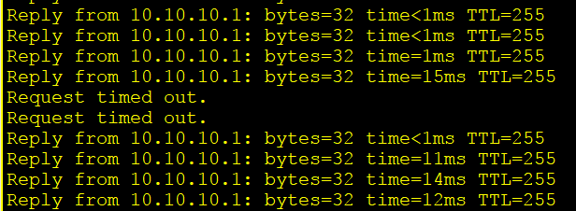

1. Verify R2 has transitioned to HSRP active.

R2#show standby GigabitEthernet0/1 - Group 1 State is Active

9 state changes, last state change 00:33:44 Virtual IP address is 10.10.10.1

Active virtual MAC address is 0000.0C07.AC01

Local virtual MAC address is 0000.0C07.AC01 (v1 default) Hello time 3 sec, hold time 10 sec

Next hello sent in 0.074 secs Preemption disabled

### Active router is local

Standby router is unknown, priority 110 Priority 100 (default 100)

Group name is hsrp-Gig0/1-1 (default)

1. Wait for R1 to complete booting and HSRP to come up. Verify R1 transitions to HSRP active because pre-emption is enabled.

R1#show standby GigabitEthernet0/1 - Group 1 State is Active

5 state changes, last state change 00:00:38 Virtual IP address is 10.10.10.1

Active virtual MAC address is 0000.0C07.AC01

Local virtual MAC address is 0000.0C07.AC01 (v1 default) Hello time 3 sec, hold time 10 sec

Next hello sent in 2.533 secs Preemption enabled

**Active router is local** Standby router is 10.10.10.3 Priority 110 (configured 110)

Group name is hsrp-Gig0/1-1 (default)

1. Hit ‘Ctrl-C’ to cancel the ping on PC1. If you scroll back you should see a dropped ping or two as R1 transitioned back to HSRP active.

